THE LITTLE FIR TREE

RTC

- “I wish I had green leaves like my other friends “
- Who is ‘I’ referred here?
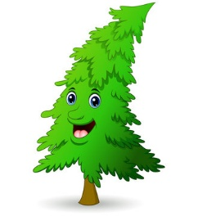
- Why does it want to have green leaves?
- What happened after this?
- Make one sentence with ‘wish’.
- “I would like to reward you. Ask for four wishes and I will grant them”
- Who wanted to reward whom?
- Why did he want to reward ?
- What was the first wish that was granted?
- Antonym of reward is-
- Punish
- Honour
- Prize
- Service

